Chapter 5

SYSTEM DESIGN
________________________________________________

INTRODUCTION
During analysis, the focus is on what needs to be done intendment of how it is done. During design, decisions are made about how the problem will be solved, first at a high level, then at increasingly detailed levels.
System design is the first stage in which the basic approach to solving the problem is selected. During system designing the overall structure and style are decided. The system architecture is the overall organization of the system into components called system. System design deals with transforming the customer requirements, as described in the SRS document, into a form that is implement able using the programming language. Certain items such as modules, relationships among identified modules, data structures, relationships between the data structures, and algorithms for implementation should be designed during this phase.
As a system designer we are tried to take following design decisions:
- Organize the system into modules
- Organize sub-modules for each module
- Allocate tasks to processors
- Choose an approach to manage data store
- Handle access to global resources
- Choose implementation logic

  - DATABASE DESIGN

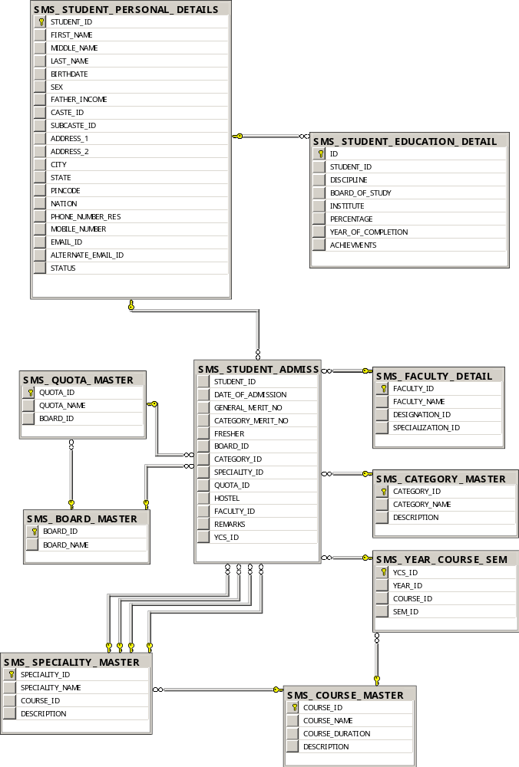
Figure 5.1 Data Diagram(Admission Module)
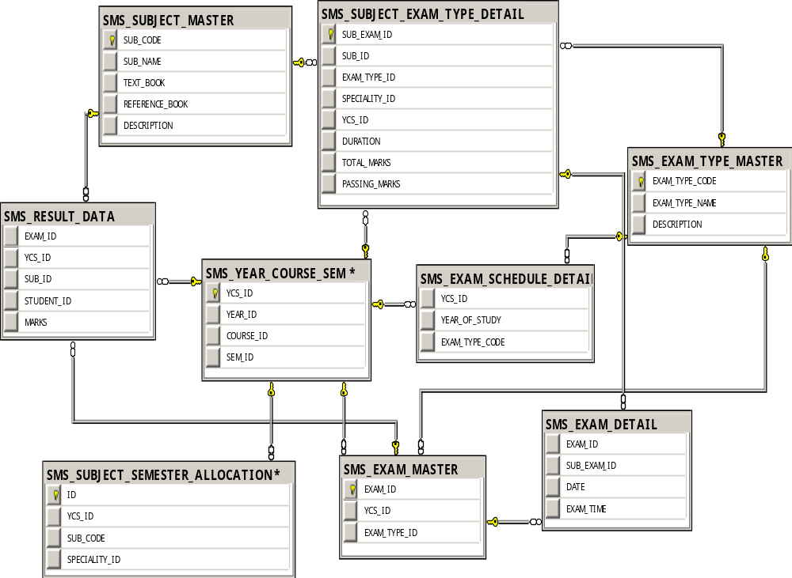
Figure 5.2 Data Diagram (Examination Module)

  - ACTIVITY DIAGRAM

5.2.1 Activity Diagrams

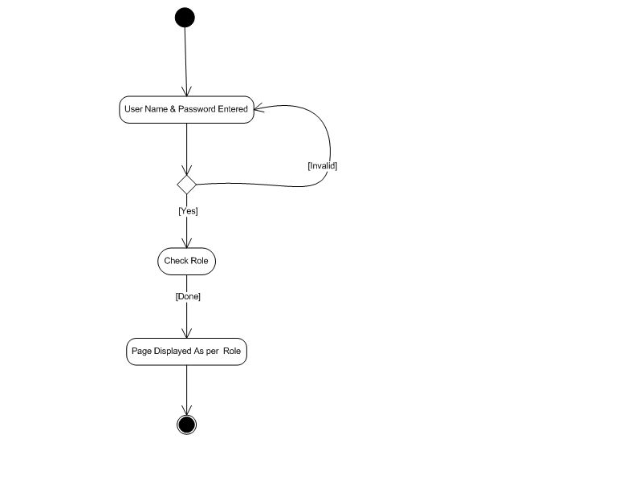

Fig 5.3 Activity Diagram for Login

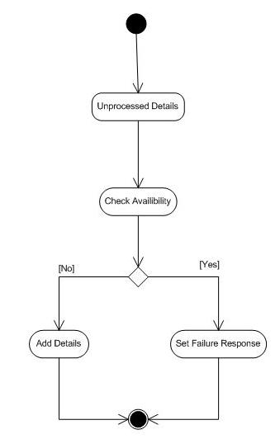

Fig 5.4 Activity Diagram for Adding Board, Quota and Designation
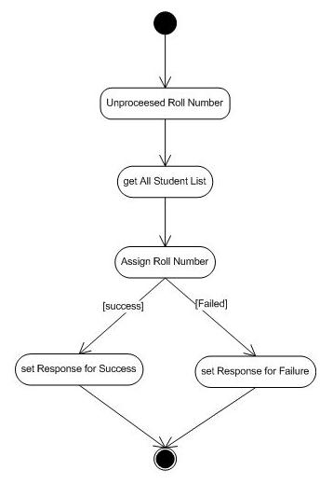

Fig 5.5 Activity Diagram for Assign Roll Numbers

Fig 5.6 Activity Diagram for configuring Fees Details

Fig 5.7 Activity Diagram for Getting Admission

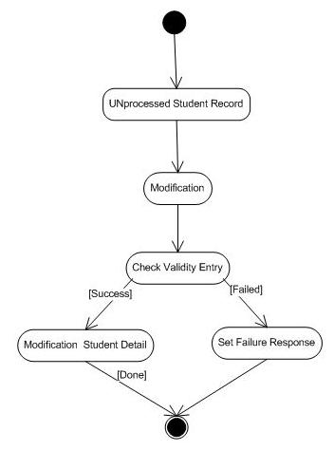

Fig 5.8 Activity Diagram for Modifying Student Details

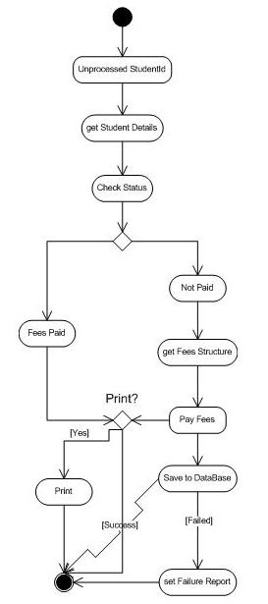

Fig 5.9 Activity Diagram for Pay Fees

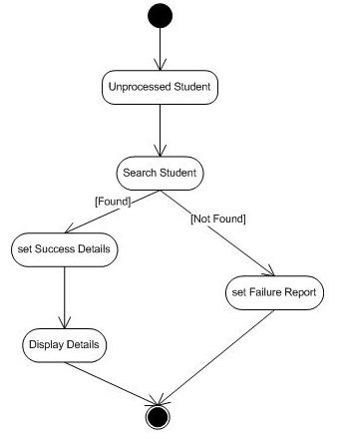

Fig 5.10 Activity Diagram for Searching Student

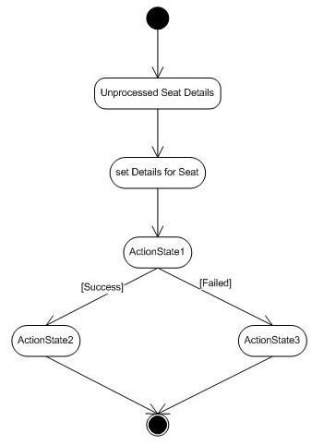

Fig 5.11 Activity Diagram for setting Seat for Admission

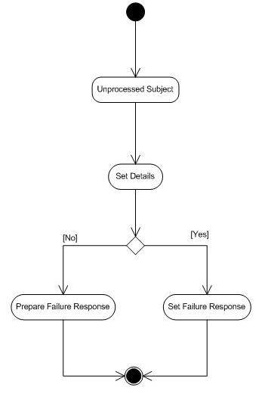

Fig 5.12 Activity Diagram for setting Subject Details

